Method

Design
This study is based on a within subject design. The independent variable is the difficulty of the game (easy, neutral and difficult) determined by which feedback loop was active. Each participant played Pac-Man with all three feedback loops.

The dependant variable was the players’ gaming experience, which was manipulated by exposing the participant to the feedback loop. Accordingly, the following design scheme was obtained for the experiment:

X_{A} → O₁ → X_{B} → O₂ → X_{C} → O₃

X_{A} is the Pac-Man game containing feedback loop A.
X_{B} is the Pac-Man game containing feedback loop B.
X_{C} is the Pac-Man game containing feedback loop C.
O₁, O₂ and O₃ are the observation sessions of the effect of the previously played game session on the players’ gaming experience. The participants answer a Game Experience Questionnaire in these sessions.

The feedback loops had the following designs:
- Feedback loop “A”. This loop aimed to reach specific GSR-, EMG-, and Pressure-values which corresponded with a difficulty level which the participants found “not too difficult“. The loop attempted to remain between the difficulty levels which the participants had indicated to be too easy and too difficult during the calibration session. (Figure 1)
- Feedback loop “B”. This loop aimed to reach specific GSR-, EMG-, and Pressure-values which corresponded with a difficulty level which is continuously a little too high for the participants. In other words, the loop adapted between levels of difficulty were somewhat above and below the level of difficulty that the player had indicated to be too difficult during the calibration session. (Figure 2)
- Feedback loop “C”. This loop aimed to reach specific GSR-, EMG-, and Pressure-values which corresponds with a difficulty level which is continuously low for the participants. In other words, the loop adapted between levels of difficulty that were near to the level of difficulty that the player had indicated to be too easy during the calibration session. (Figure 3)

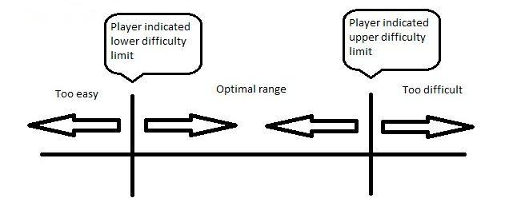
Figure 1: Optimal Range for Feedbackloop "A"
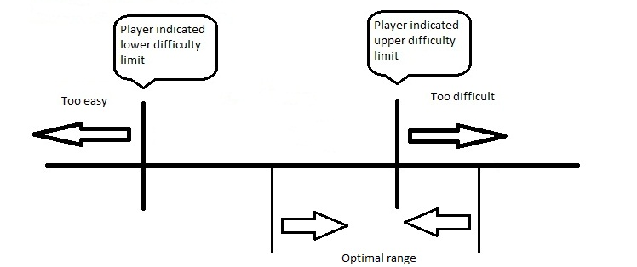
Figure 2: Optimal Range for Feedbackloop "B"
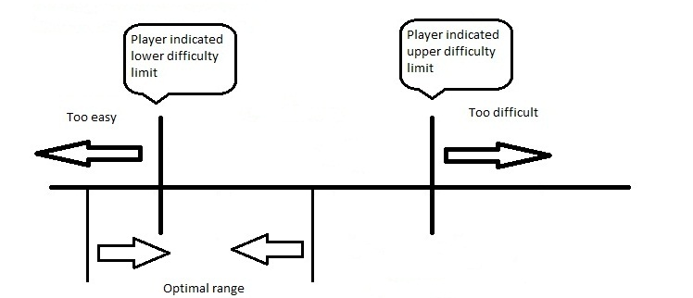
Figure 3: Optimal Range for Feedbackloop "C"

The participants were presented with the feedback loops in differing orders in such a way that every combination of orders is tested. With three conditions, 6 different combinations are possible. Thus a multiple of 6 participants were needed. It was decided that 24 participants would be sufficient. A combination will be assigned randomly to the participant, but in such a way that all combinations are evened out among all the participants (each combination is tested 4 times by 6 different individuals).

Participants
The 24 participants in our experiment were mainly students or ex-students, ranging in age from 18 to 25. Participants were both men and women. The participants were asked to indicate their age and gender at the end of the experiment.
Through a mailing to friends and acquaintances volunteers were drafted for the experiment. Prior to the experiment, the participants washed their hands (without using soap) and filled in a basic questionnaire in the game room. The participants were required to shave themselves and not to wear make-up during the experiment. The participants watch a 8-minute peaceful movie (“Aquatic Movie”) in advance. This helps in obtaining a baseline for the participants.

Apparatus
The participants’ physiological state was measured through 1) a DualShock3 controller to measure the pressure which the participant exerted on the control buttons, 2) electrodes on facial muscles used during smiling and frowning and 3) a strip for measuring skin conductance was applied to two fingers of the non-playing hand. These devices communicated their values through a Mobi HTI. Accordingly, these values were interpreted by our Pac-Man program in C# (programming language).

Prior to starting the calibration session, the participants watch a calming, aquatic themed movie.
During the calibration session, the participants indicated whether they think that the game is too difficult or too easy. They used the L1 and R1 button to show their experience (L1 for too easy and R1 for too difficult).
At the end of every adaptive session, the participants answered a Game Experience Questionnaire to indicate how they experienced the game (see Appendix A). Once the adaptive sessions were completed, the participants were given a questionnaire to indicate gender, age and experience with gaming – and Pac-Man in particular – and to indicate whether they have noticed the changes in speed during the adaptive sessions.

Procedure
The participants were welcomed and asked to wash their hands. Then they were guided to their seat on the couch. They were then instructed on the calibration session, the electrodes were attached to their facial muscles for smiling and frowning and the GSR strip was applied to two fingers of the non-playing hand.
Before starting with the calibration session, the participant is asked to watch a 8 minute, aquatically themed video to calm down so that a reliable baseline can be measured.

The calibration session was performed to determine the GSR-, EMG-, and Pressure-values for the participants when they indicate that the game is either too difficult or too easy. At first, the game difficulty gradually became higher until the participants indicated that the game was too difficult. The GSR, EMG-, and Pressure data were then recorded and stored in a users’ profile. Consequently, the game difficulty gradually decreased until the participants indicated that the game had become too easy. Again, the GSR, EMG-, and Pressure data were recorded and stored in a users’ profile. This continued for 5 rounds and, in total, took about 20 minutes per participant.

After completing the calibration session, the participants were instructed on the next stage. The participants played three adaptive sessions (5 minutes per session). The adaptive games were assigned in random order to the participants. During the sessions, the game detected whether the game was considered too easy or too difficult, based on a comparison between the GSR-, EMG-, and Pressure-values and the stored users’ profile. Subsequently the game changed the difficulty level depending on the type of feedback loop the participants were presented with.
After every session, the participants were given a Game Experience Questionnaire to indicate their emotions after playing the game.
When the three sessions were completed, the sensors were removed and the participants were given a final questionnaire which contained some standard questions such as age and gender, but also some questions to verify whether they could notice when the game changed its difficulty and such. After completion the participant was debriefed and thanked and paid for their participation. They were given the opportunity to ask questions concerning the experiment. If they wrote down their email-addresses, the results of the research were sent to them.

